THE 4TH INTERNATIONAL CONFERENCE ON ADVANCED CONCEPTS ON MECHANICAL ENGINEERING – acme 2010
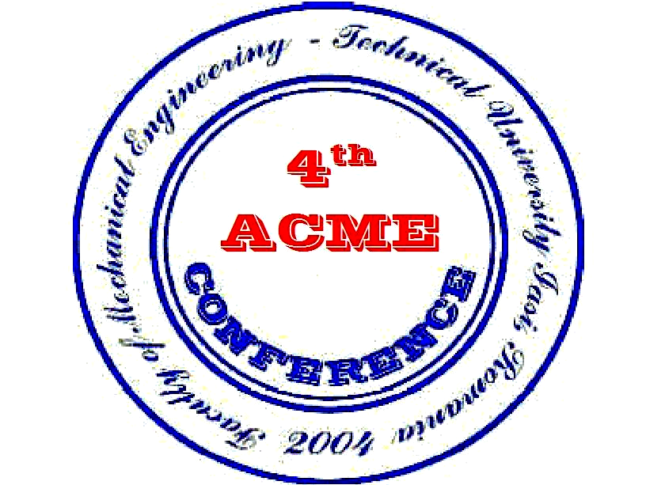
17 – 18 JUNE 2010
IASI
Romania

Note of attendance
Name and surname:
Position and institution:
Mail address:
Phone number:
E – mail:
Title of the paper:
Authors:

Date and hour of arrival By plane By train By car
□ □ □

Date and hour of departure
□ □ □

Accomodation option

Traian Hotel Unirea Hotel Astoria Hotel Moldova Hotel
□ □ □ □

T23 Hotel Ceramica Hotel T20 Hostel
□ □ □

